Analysis

# Section 1

## Background

During any A-level science subject, a student will be required to carry out investigations based on their theory work. These experiments will be recorded in a lab book, and handed in to the teacher. There will be a total of twelve required experiments (AQA exam board) which must be completed and marked by their teacher. This process can be tedious and stressful for both the teacher and student, and is an area of work where students often find themselves slacking. If this happens, and a student falls behind with their lab book, it can be detrimental towards their theory work and revision for upcoming exams.

My program will aim to target this, offering a new way to aid students to catch up with this section of work. It will consist of multiple AQA A-level practical experiments for students to carry out in their free time, with the ability to save results for teachers to later view. There will be two different user types to accommodate both teachers and students, each with different interfaces. The student will be able to select an experiment to carry out, collect results from this experiment and save it locally to a folder. The teacher will also be able to view these results, and which student has carried out each experiment.

As some teachers may have multiple classes, my program will also use a class-based system for teachers to create and edit each class where necessary. This will help teachers to organise their students to match their account as similarly to real life as possible.

I will aim to implement at least four of the twelve experiments to an appropriate level of accuracy. The experiments I am currently considering are:

The Stationary Waves investigation

Young’s Double Slit experiment

The Snell’s Law experiment

# Section 2

## Research

## Standing Waves experiment

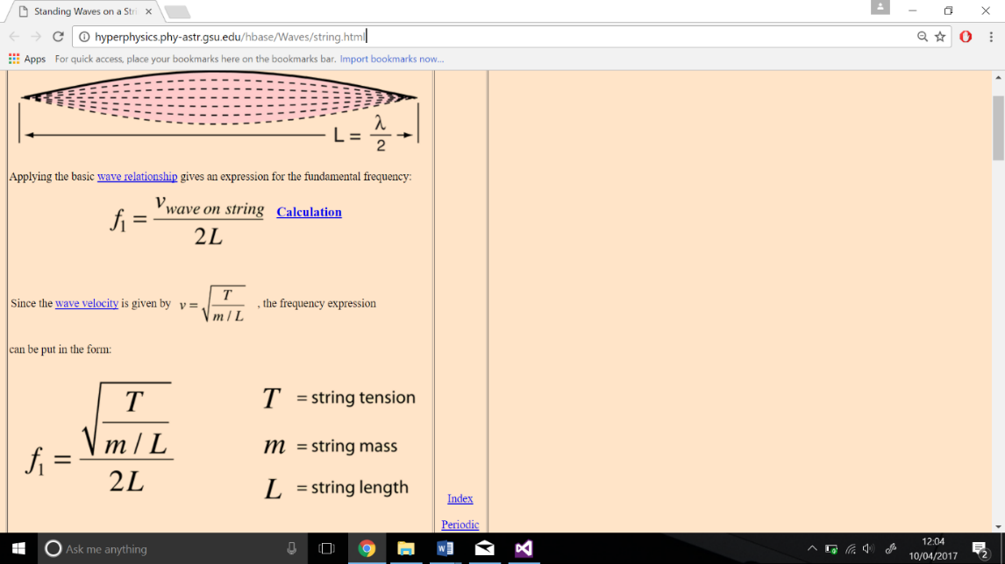To implement the correct equations as effectively as possible, I had to first do some deeper research into the formulation of the equations themselves. I looked online and found a helpful HyperPhysics article: <http://hyperphysics.phy-astr.gsu.edu/hbase/Waves/string.html>

**Figure 1**

From this, I found the equations in **Figure 1** above to, showing how to find the fundamental frequency of a specific string set-up.

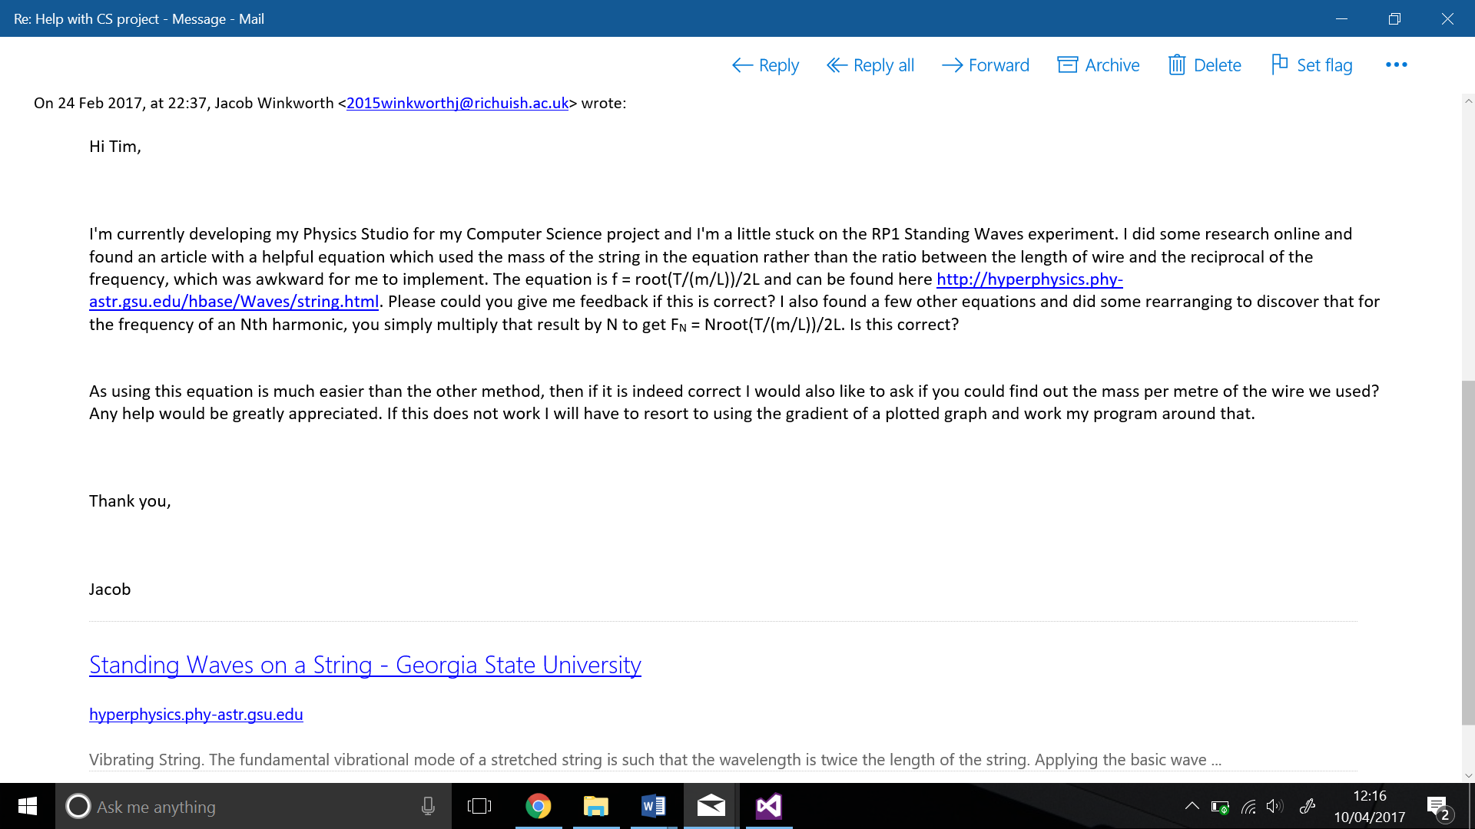I later discovered that for the Nth­ harmonic of a specific string set-up, the equation is simply multiplied by N. Such that . To ensure I was correct, I later emailed my Physics teacher Tim Hunt to give me confirmation. Here are the screenshots of our E-mail conversation:

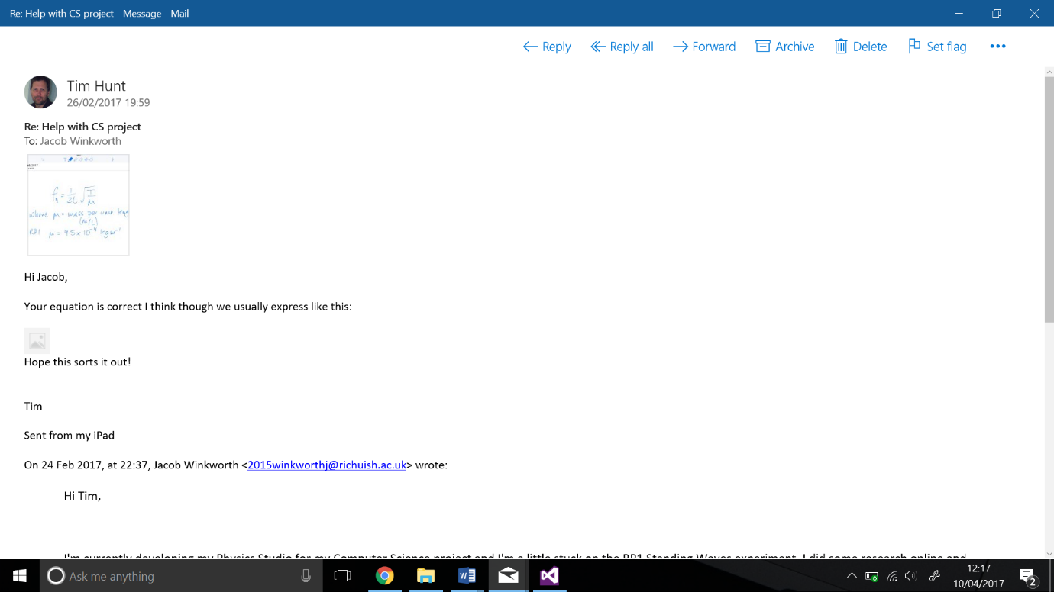

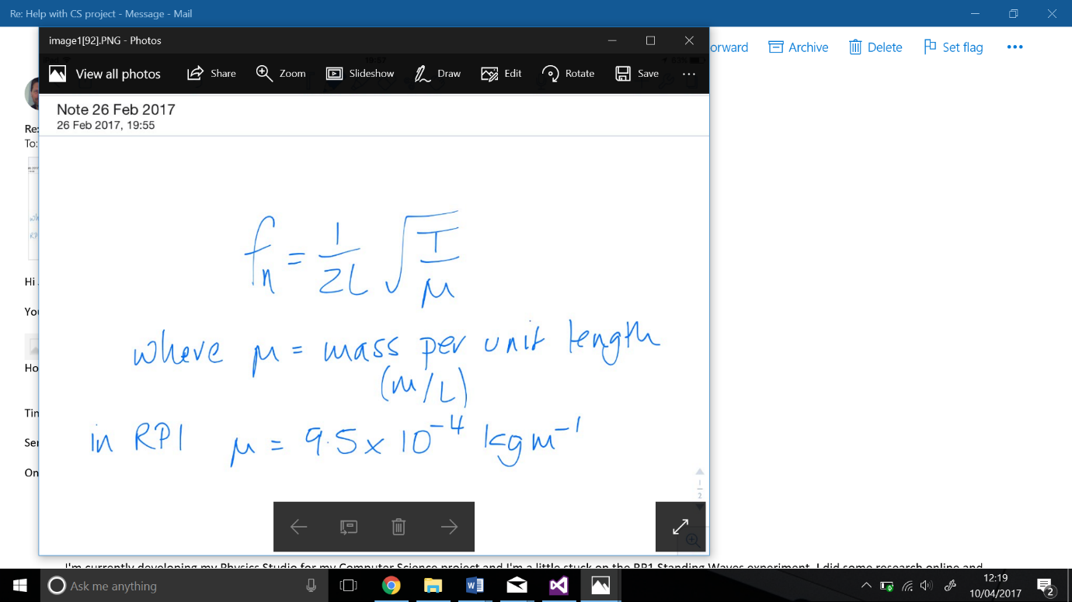This was the attachement sent with Tim’s reply:

This allows me to use the correct value of the actual mass per unit length we used in class within my program.

## The Young’s Double Slit graph

To further help with the visualisation of Young’s double slit experiment, a graph describing the different intensities of light should also be displayed.

However, I faced an issue when attempting to find an equation which could be used to accurately plot a graph. Although online applications such as Desmos were helpful when experimenting with different variations of cosine graphs, which had a reasonable similarity to the actual interference seen, I felt it necessary for it to be of greater accuracy.

To achieve this, I had a friend post a Quora thread online. Here is the link: <https://www.quora.com/Is-there-an-equation-that-accurately-describes-the-double-slit-interference-pattern>

The success of which was overwhelming, with answers posted by people with skill sets from degree all the way up to doctorate level. The most useful of which coming from Bryony Lanigan, who studied at the University of New South Wales. The equation she gave is as follows:

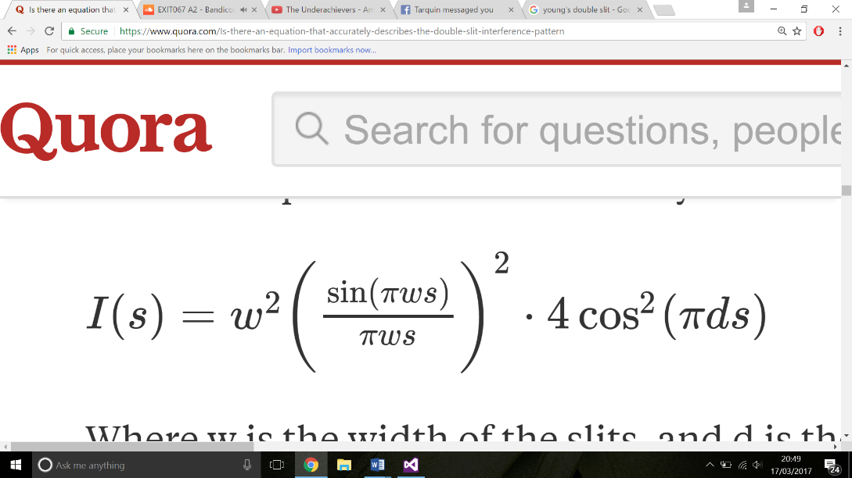‘Where *W* is the width of the slits, *d* is the distance between the slits and *s* is the s is the **reciprocal space vector**, and represents the spatial frequency’

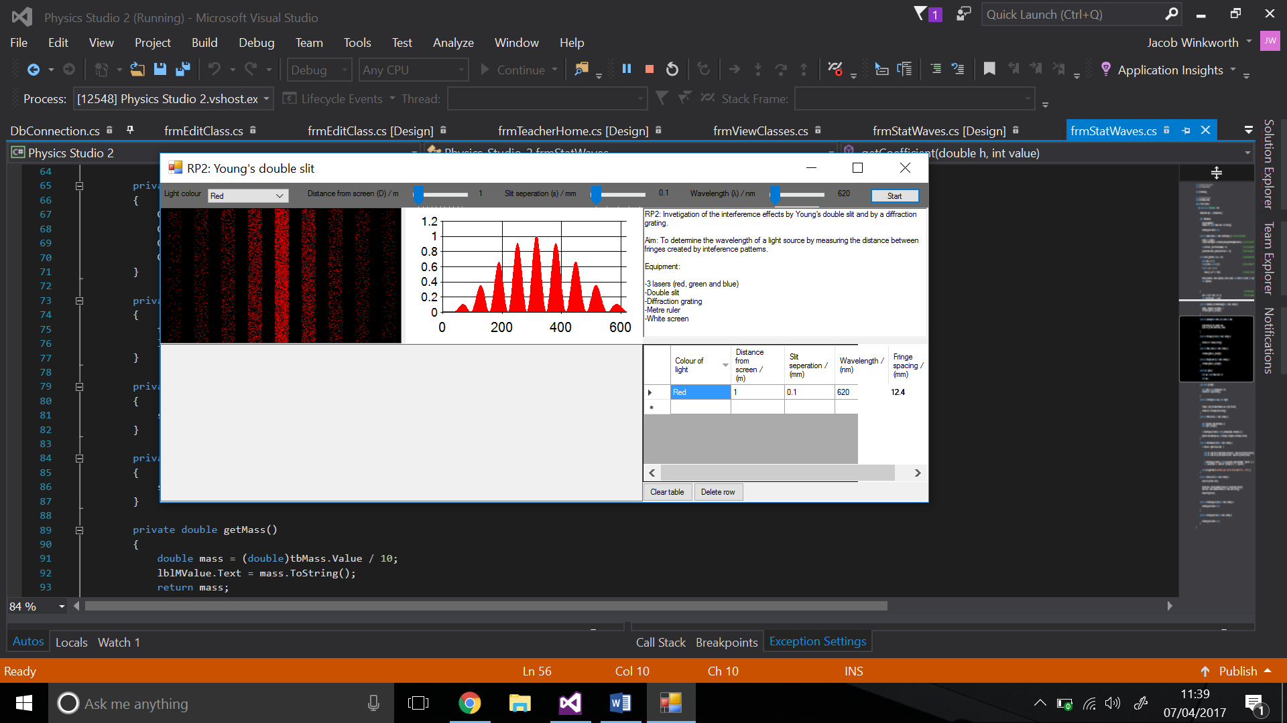Using this equation in **Visual Studio** using the **Graph** control forms a graph as follows:

## Teacher questionaire

As a teacher of Physics, Tim Hunt is also a prime example of an end user for my program. Therefore, in order to acquire a good level of primary research, I handed him this questionaire:

The feedback from which was:

## Student questionaire

The second type of end user that will primarily be using my program are students much like myself. As such, I composed this second questionnaire and handed it around to my fellow classmates:

The graph below shows the average answer for each of the questions asked:

# Section 3

## Objectives

1 The program needs to include a ‘sign up’ option for students.

* 1. The user needs to be able to input their name for the system
  2. The user needs to be able to input a username of appropriate length for the system, i.e. 5 characters.
  3. The user must be asked for a password of appropriate security, i.e. at least 6 characters.
  4. The user will be asked for the teacher’s ID of which they need to connect to, which must be checked for validity.

2 The admin account must include an option to add a new teacher

* 1. For a teacher to have their account added, they must consult the school’s administrator. Then,

the administrator can use the admin account to add a new teacher.

2.2 The admin will then be able to input the teacher’s name from here.

2.3 The admin will then be able to input the teacher’s ID from here.

3 All login details must be stored in an appropriate SQL database

3.1 In the database, one table is to be used for teacher login details, one for student login details, and

a junction table that uses a compound key between the student and teacher IDs.

3.2 When storing the passwords for each account, they must first be run through a hashing

algorithm before being added to the database.

3.3 All SQL parsed through the database should be parameterised to avoid SQL injection.

4 A class system should be used for teachers to track specific classes separately, as they may have multiple classes.

4.1 After signing up – as default – the student will not be assigned a class.

4.2 The teacher should be able to add numerous amounts of students to a class. One student should

only be allowed in one class.

4.3 To ensure this is made as easy as possible for the teacher, they should be able to search

for specific user IDs.

4.4 The class number of this student will then be added in the ‘connections’ table, along with the

composite key of their student ID and their teacher’s ID.

5 There must be at least 3 working experiments from the A-level Physics AQA syllabus

Each experiment must include:

5.1 A briefing of what the student must do to correctly carry out the experiment.

5.2 A visual aid for the experiment set-up.

5.3 A graphical display of the result of the experiment.

5.4 A way for the student to record and graph their results.

# Section 4

## Entity relationship diagram:

1

1

∞

∞

This shows the relationship between the ‘students’ table, the ‘connections’ table and the ‘teachers’ table. The connections table is used as a junctions table, using a composited key composed of the ‘StudentID’ and the ‘TeacherID’.

**Objective link:** 3.1 In the database, one table is to be used for teacher login details, one for student login details, and a junction table that uses a compound key between the student and teacher IDs.